6/12/2020

Muhammad Zain

Muhammad Maaz

Shahroz Khan

Wahab Ijaz

Movie Review



National University of Computer and Emerging Sciences



Final Semester Project

|  |  |
| --- | --- |
| LAB INSTRUCTOR | Rida Akram |
| Semester | Spring 2020 |
| Movie Portfolio | Turbo |

Communication and Presentation Skills Lab

Portfolio

# What movie? Why?

We have discussed a lot of movies and then we choose **TURBO**, because the value of motivation and the aim of movie maker to present a lot of success ideas indirectly via the story of snail. Because achievements seem to be connected with actions. This movie contains such type of action packs which will motivate you to stay focused and to believe in your dreams and to work hard to achieve the dreams.

# Review/Summary

TURBO is a high-velocity 3D comedy about an underdog snail whose dreams kick into overdrive when he miraculously attains the power of super-speed.

If we look at the financials of this movie which is not quite dramatic.

|  |  |
| --- | --- |
| **Opening Weekend:** | $21,312,625 (25.7% of total gross) |
| **Legs:** | 3.90 (domestic box office/biggest weekend) |
| **Domestic Share:** | 28.9% (domestic box office/worldwide) |
| **Production Budget:** | $135,000,000 (worldwide box office is 2.1 times production budget) |
| **Theatre counts:** | 3,806 opening theatres/3,809 max. theatres, 4.3 weeks average run per theatre |
| **Infl. Adj. Dom. BO** | $93,036,440 |

~[Thenumbers.com](https://www.the-numbers.com/movie/Turbo#tab=summary)

Turbo is about a snail voiced by Ryan Reynolds and he dreams of being fast he watches the Indy 500(Car racing ) he looks at the winner who actually win the race and listens to their speeches and just wants to be like them he wants to be faster than all of his snail fellows He goes to his job in tomato garden everyday which is essentially a monitoring tomato garden yard and the house out in the potted plans of this persons house and during the day he tries to run from a child on a little bike who tries to crush the snails and they have to lookout for birds to look out for birds that sometimes come down and pick them off one day he gets blown inside the engine of a car in the middle of the street race and get injected with nitrous oxide and become a super snail who can go faster than any other snails and from then we get to see how he gets to reach that dream to be fast and waiting to be In the Indy 500 now there are certain type of kids movies

# Plot/Structure

## C:\Users\HP\Desktop\images.jpg

After a freak accident infuses him with the power of super-speed, Turbo kicks into overdrive on an extraordinary journey to achieve the impossible competing in the world's fastest race, the Indianapolis 500. With the help of his tricked-out streetwise snail crew, this ultimate underdog puts his heart and shell on the line to prove that no dream is too big, and no dreamer too small. A freak accident might just help an everyday garden snail achieve his biggest dream. The snail is very dream about to fast run like a fast car as he watches in the tv.

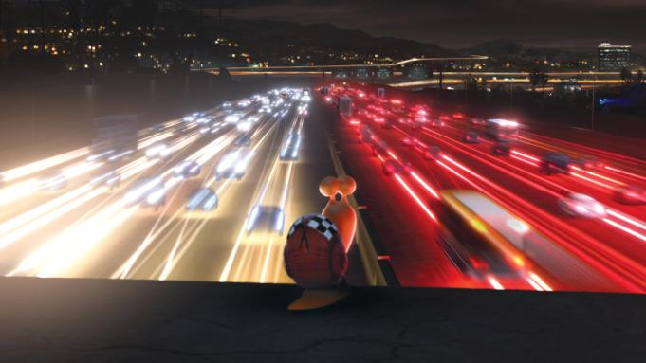

A snail named Theo is unhappy that he's slow. When he watches car races on TV, he wishes he could as fast as them and renames himself Turbo. One day through a series of mishaps, he ends up on a car that's in the middle of a street race. He gets sucked into the engine and when the driver hits the nitrous oxide which makes the car go faster. He gets out and discovers he can move fast. Eventually he and another snail, Chet get picked up by a guy who and some other people race snails. When they see how fast he is, they decide to enter him in the Indy 500 which is what Turbo wants.



Theo a small garden snail is probably the only snail in the garden who is obsessed with speed and racing. Everybody is against it even his older brother, Chet When he accidentally wrecks the garden, he runs off but lands himself in an accident that upgrades him. When he suddenly develops super-speed, he teams up with fake racing snail a team to compete in a challenge he loves-the Indy 500.They all other snails are also a fan of racing and he was enjoyed a lot to see his found in the racing. The Tito which help the turbo to play the race he was very loving and kind too snails

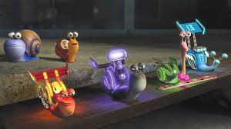

the garden snail Theo dreams on being the fastest racer in car races and worships his idol, the champion who has won the Indianapolis 500 several times. His brother Chet protects him most of the time from daring situations caused by Theo. When Chet rescues Theo from a failed attempt of recovering a prize tomato, Theo leaves the garden feeling humiliated. Soon he is accidentally sucked by the supercharger of a racing car and he drowns in the nitrous oxide injected to speed up the car. On the next morning, Theo finds that he has achieved speed power. When a crow picks Chet from the garden, Theo pursues them and rescues his brother. However, they are captured the taco truck driver Tito and brought to a snail race. When Tito sees the performance of Theo. Turbo, in a race with the other snails he decides to enter Turbo in Indianapolis, despite the disagreement of his brother Angelo. But his neighbors share the entrance expenses and they head to Indianapolis

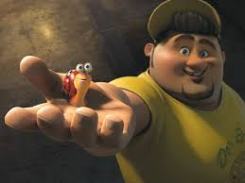

Turbo may live life at a snail's pace, but his dreams charge along at light speed. Whenever Turbo closes his eyes, he sees himself zooming past the checkered flag at the Indianapolis 500, and leaving all his competitors in the dust. Unfortunately for Turbo, all his fellow snails including his brother Chet seem to savor the slow life. Then, one day, it happens Turbo gains the ability to travel at speeds up to 200 miles per hour. Turbo is during mastering his newfound ability when he and Chet are unexpectedly captured by Tito. Tito quickly takes his two newest racers where all the speed-freak snails await their next run on the track. It's there that Turbo makes some colorful new friends and learns to have some fun while talking the competition. But his adventure is still far from over, and by the time Turbo realizes that his dreams are finally within reach, his newfound family will be right there to cheer him past the finish line.

# Themes

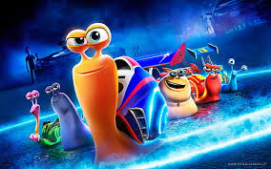

Themes that run throughout the movie and are reinforced constantly include believing in yourself, following your dreams, and never giving up. Kids will find the silly characters endlessly amusing, with only a little bit of innuendo, stereotyping, and potty humor to contend with. The biggest concern is the repeated scenes of peril, in which the beloved snails seem to be in danger thanks to a lawnmower, a busy freeway, plentiful crows, and a car crash. But all scenes involving major characters are resolved positively.

**Turbo** is a funny animated underdog comedy with strong positive messages There are different perspectives of seeing things. It all depends on you that how in the world you deal with your sight. Turbo the snail was always optimistic and he never let his weaknesses lessened his unbelievable and extraordinary power. His powers were no less than super powers. After going through the movies, one can easily understand the power of self-belief. There are a lot of morals and themes that we get at the end of the movie. They are listed below:

* + Self-belief
  + Will power
  + Not giving up upon anything
  + Not letting your fears take control of you
  + Get yourself a good company because your personality depends a lot on your company.
  + Power of group work
  + Learning through failures
  + Optimistic approach in life

So basically, the whole movie is a mixture of many real-world morals. Since the negative side of our living world in the movie is also show like the STEREOTYPING of humans that Turbo faced due to his small size and the because of the fact that he is a snail. No matter the world thinks about you, one thing that you always have to stick with is never lose your hope.

**“BELIEVE IN YOURSELF”**

# Characterization

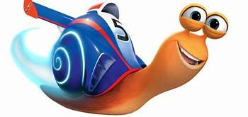

TUBRO(THE0) is the main character of movie who lives in a tomato garden with his snail community having a dream of being the fastest and best racer of entire world He always tries his best to overcome his slowness and loves to see the Indy 500 race on television and he is also a big fan of GUYGAGNE who the five-time champion of Indy 500 race.

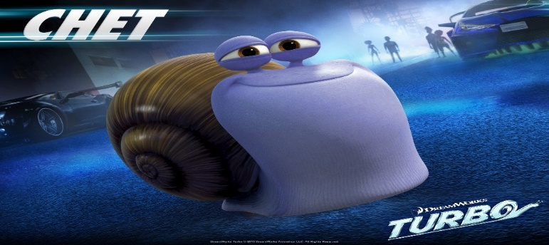Chet character is the fatty purple snail who plays the role of as THEO brother who always said to him that focus on the work of tomato and don’t even think of his mad of being fastest because snail can’t do that it is against the nature of snail. He always feels embarrassed when he sees his brother has obsession with speed.



Tito is the human character in the movie who ran a taco shop with his brother Angelo in the plaza, which is not much famous, so people don’t come there much and due to this they don’t earn enough money. Tito loves to make a race between snails he has already different snails and then the incident happens with Turbo and he found them.

Angelo is the brother of TITO they both run taco shop together he always advice his brother to focus on taco shop and don’t waste their time in snail race because these races didn’t give them any money. Angelo character play a vital role because the money to take part in Indy race is given by a shop of Angelo and Tito

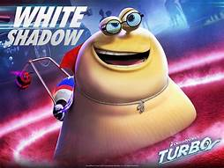

White shdow name snail is few of those snail who live in the garadge of TITO and make races.his name is white shadow because he thought that he is fast like shadow.

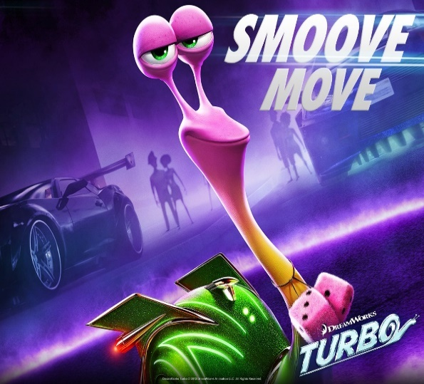

Smoove move is the kind of snail. A super cool rider and he has a unique perspective about that race in which turbo takes a part. .

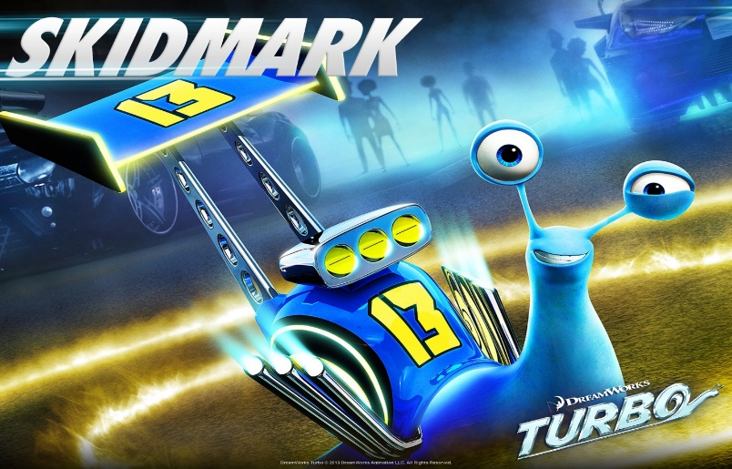

Skidmark brilliant and inventive he is a team thinker inventor and mechanical snail he thinks that if a turbo wins the race it will be a great honour for sanils so he helped turbo in persuing his dream.



Burn is only female snail in the racers burn was orignally turbo love intrest but she came become chets love intrested instead.

First he was in love with turbo then he changed his relationship and then he repent on his fully.

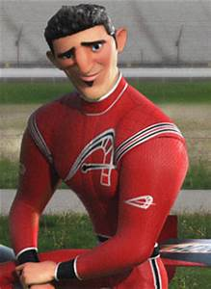

Guy is a french-candian race driver and five time-indy 500 champ,guy comes across as an eccentric yet christamatic charmer but he really a competitive egomaniac who will do anything to win.he is all speed no heart.

# Visuals (Setting, colors, symbols, objects)

   
Basically, by Visualization or visuals we mean something relating to sight, or to things that you can see. The graphic **visual** depiction of violence, music, film, dance, and the **visual** arts.

This could be in a song, movie, article or in any presentation.

In visualization following factors are impact the most:

* Picture
* Colors
* Lights
* Charts
* Context
* Background of any picture
* Table
* Maps
* Graphs

In Animated movies like TURBO visuals matter a lot because if a movie has good picturization and good combination of colors are used then the movie is most likely to watch. Since most of the animated movies are especially made for kids, the graphics should have a minimum effect on kid's eyes because they are more sensitive than adults.

There are a lot of scenes from the movie TURBO which convey us great messages and shows us the real world. Some of the meaningful picture taken from the movie are briefly explained and examined below:

**PICTURE : 1**

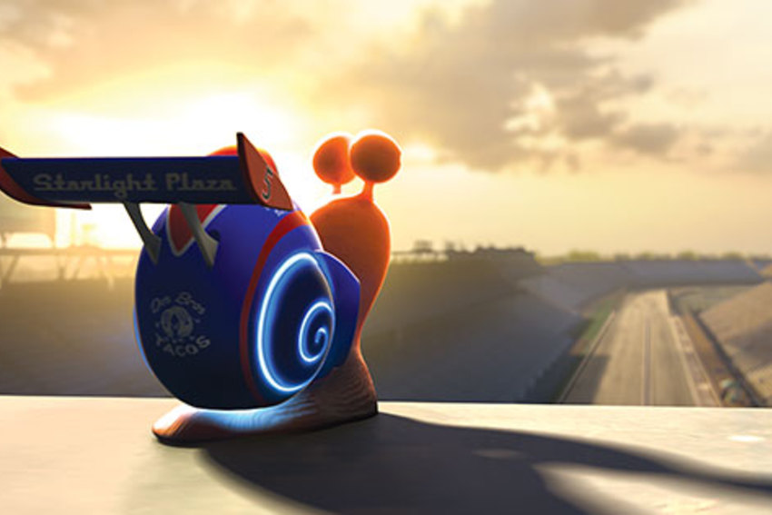

From the above picture the main points that comes to one's mind are:

* Sunset
* Long road
* Turbos shell
* Black clouds

So first of all, we can clearly see that main source of light in the picture is Sun. No matter that the sun is setting but still it's worth remains the same. It is providing enough light that turbo can see each and every thing around him easily

Secondly, we can see that turbo is looking towards the long road. Long road is basically depicting the “LONG ROADS OF LIFE" in front of which we are too small. But we have to take these long and lengthy routs if we are willing to fulfill our dreams and goals. Despite of the fact that turbo is all alone but still his main focus is on his goal. This is something which makes him special.

At last if we dig deeper in the picture, we can relate sunset with turbos shell but How?

See the sun is providing adequate light meanwhile the shell of turbo is igniting. It's all boosted up. This depicts that there is hope and will power inside turbos head. And when there is hope you gain power.

**“Once you choose Hope, anything is possible"**

~ Christopher Reeve

So, in the end we can conclude by saying that the whole picture is depicting the word hope and it is giving you very positive vibes.

**“Hope give you the strength which**

**you need in life to fulfill your dreams"**

**PICTURE: 2**

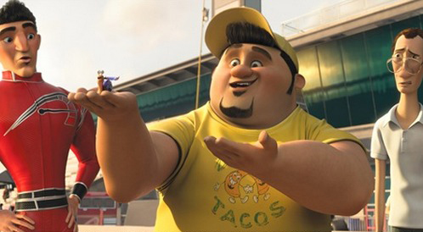

There are three men and a snail in this picture. So main things to focus on are:

* Titu
* Guy Gagne
* Assistant
* Turbo
* Stadium

This picture is taken from a very special event from the movie. All the men are in a stadium, I'd say a car racing track. Since Titu is pointing towards turbo while others around are looking at Turbo the snail. So, we clearly see that the focus in this picture revolves around Turbo. Very bright lights are used in this picture which makes the scene happier than to be a dramatic one. In this scene Titu being Turbos friend and trainer has taken turbo in his hands and showing the whole audience that this TURBO. He’s the one who is the fastest snail in the world. Here Titu introduces Turbo and declares that he will be participating in the race. In the picture World famous car racer Guy Gagne is also present who was having a press conference while titu came in. He is shocked and surprised to see Turbo in fact he is basically stereotyping turbo. He thinks that Turbo cannot win the race because he is too small to tackle and compete with huge and electros racing cars. Yet turbo is shown very small in this picture, still he is the major concern of the picture.

**PICTURE: 3**

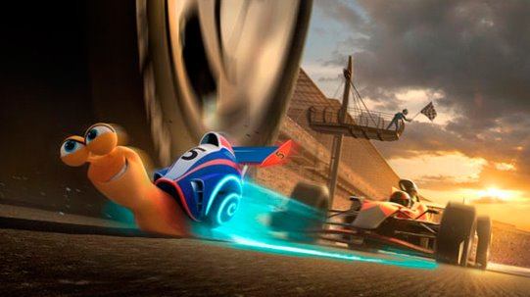

Again, the picture above is giving us something special to cope with. This scene taken from the event when Turbo is participating in car racing competition. Just behind Turbo his biggest rival Guy Gagne is also present and he is trying to overtake Turbo. But the boosted power of Turbo gives him enough power to run faster and he is crossing all the other cars one by one in current scene. The important features in this picture are:

* Sky
* Sunset
* Turbo’s Eyes

First of all, if we focus only on Turbo, we can clearly through his eyes that at that particular moment he is quite determined and he is only looking towards the finishing line. This depicts that of you are willing to achieve your goals you have to stay focused on your final destination

Secondly the sky is having black clouds and a beautiful sunset. This depicts that good and bad times always come in life in a parallel way.it depends on you that how you cope with the situation. While there is darkness in the sky because of black clouds still, the sun is giving proper light and it gives you an optimistic vibe.

So overall in the movie you see mostly optimistic visuals but there are few scenes which are quite shady. Mostly bright colors are used in the visuals and a nice and balanced color combination is maintained throughout the movie.

# Dialogues

**Chet to Theo**:



In this story time Chet asking turbo that “Are you insane Theo what were you thinking I thought I could get there but when are gone wakeup”

* It teaches us a lesson that many people around you who are loves u but are doubtful about your abilities if they don’t believe that you can’t do that thing you don’t have to lose your hope and keep doing hard work until you succeed and Theo shows his brother in the next part of story that he can do what that other snail can’t do it.

**Guygagne to press:**

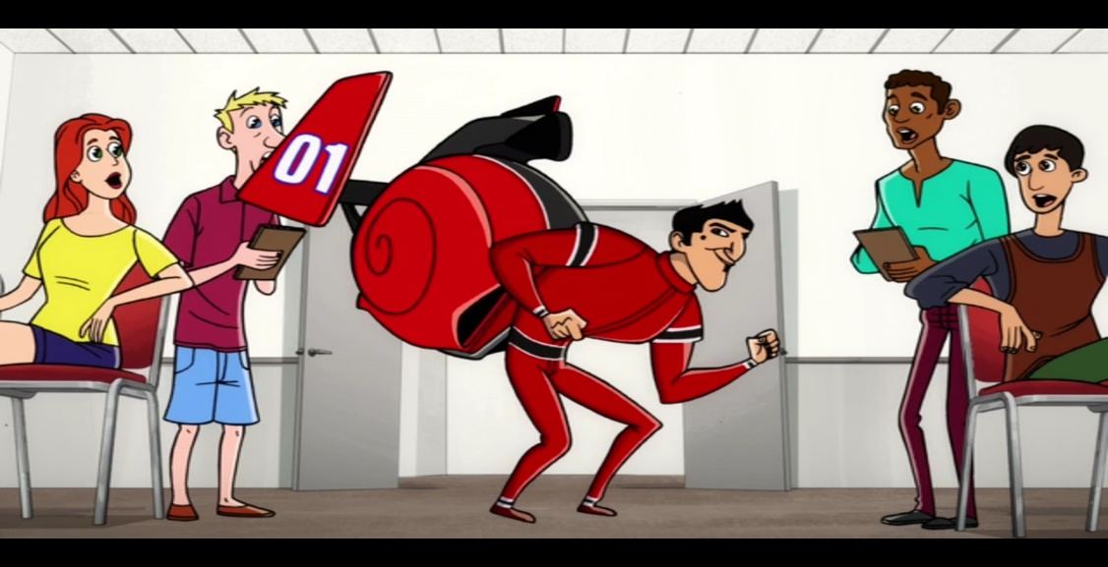

Guygagne in his press conference said some words and turbo watching on television is much impressed about that he said’ ’Well there comes a time in every race when a driver is forced to make one key split-second decision fall behind or push a head to take a chance or risk it all play it safe and suffer defeat risk it all guy to make a win”

That’s why THOE always wants a one chance in his life to show the world that what he is and nature give him that chance and he show the world the lesson that teaches us in these line is that people think their chance come and then they show the world who they are and waiting for their chance they died in real life we have to make our chance and we get this chance only by doing hard work not by finding short-wave.

**Fellow snails challenge Theo:**

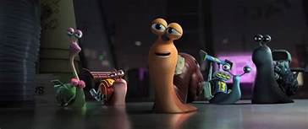

In this chapter of movie Theo meet different racer snail and Theo’s attitude is high they challenged Theo to make race and he accepted he thought that with his unusual power no one can beat him. And then race started snail with their experience pass the hurdles because those were the daily routine for them but Theo with his powerful speed can’t win because he is not familiar with that racing track.

People think that with their power and money they can win the world easily but it is impossible because nature have some rule and the person who have hard work in his pocket always better than the powerful person who only have money

**Final:**

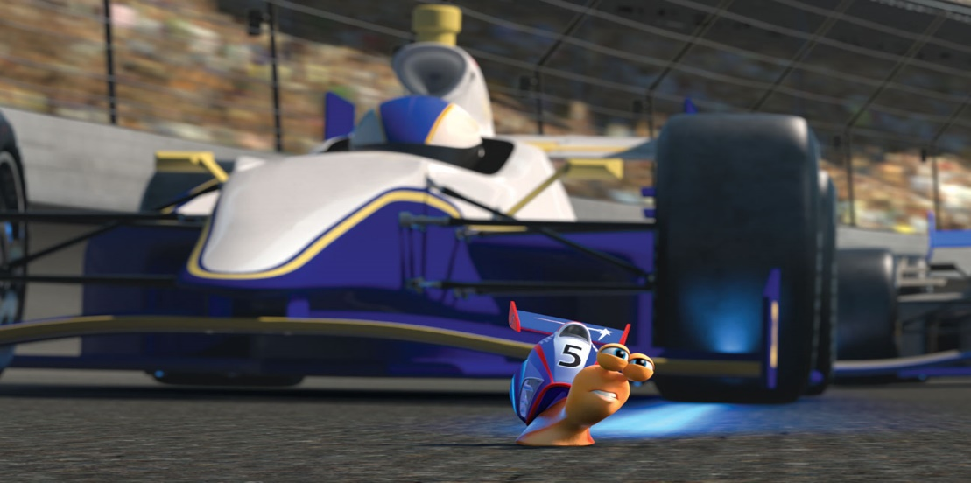

In this time when turbo thought that he can’t do that without his unusual power he can’t win the race than Theo says to turbo that “finish this, I can’t oh yes you can it is it you my little brother never gives up that’s the best thing about you so you get out there and win this turbo

The movie teaches us a lot of lessons that you have to depend on you not on others see your abilities not try to think that something unique happens and then you can do whatever you want like turbo he thought that nitrous oxide is the only thing that make him to win the race but that was him the only person at that end who win the race with his natural abilities so depend on your abilities not on others.

# Sounds



The success of any movie depends a lot on the type and quality of sound being used in the movie. Since the genre of **TURBO** is sports adventure, sounds of different cars like racing cars are heard quite often. Here is the list of sounds or say sound effects that you observe during the movie:

* Cars
* Crowd
* Joyous music
* Engines
* Crows
* Dramatic music
* Sad music
* Drums
* Gunshots
* Quick Boosts
* Tense music

So, if we notice the above-mentioned points, we clearly understand that most of the sound effect used in the movie revolves around the racing track.

Further discussion will be about the voice over’s in the movie. Then you get to know that who’s voice was behind your favorite character

The main character of the movie is Turbo. He has a good, balanced voice

His voice has been played by **Ryan Reynolds**. Ryan Rodney Reynolds is a Canadian actor, film producer and entrepreneur. He began his career starring in the Canadian teen soap opera Hillside and had minor roles before landing the lead role on the sitcom Two Guys and a Girl between 1998 and 2001.Ryan Reynolds has also played the role of **Deadpool**.



Many top artists have been hired in the making of this movie. Above we see that turbo’s voice was covered by Ryan Reynolds. Similarly, the voice of SMOOVE is also covered by top American rapper **“SNOOP DOGG “.** his voice is a bit echoey and hits differently to the listener

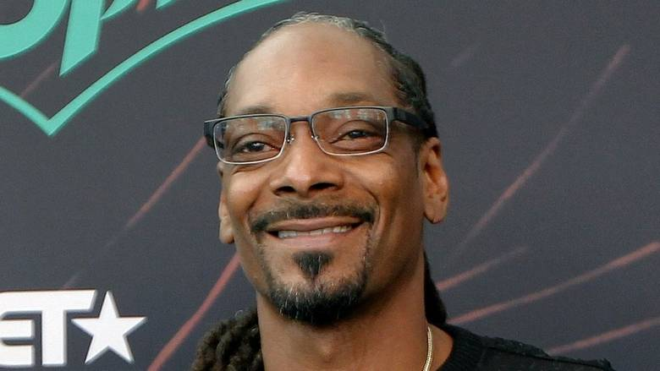

Other voice over’s in the movie are listed below:

* Kim-Ly has been covered by Ken Jeong.
* Chet has been covered by Paul Giamatti.
* Skidmark has been covered by Ben Schwartz.
* Titu has been covered by Michael Pena.
* Worker Snail #1 has been covered by David Soren.
* Burn has been covered by Maya Rudolph.
* Paz has been covered by Michelle Rodriguez.
* Samuel L. Jackson has been covered by Whiplash.
* Angelo has been covered by Luis Guzman.
* Bobby has been covered by Richard Jenkins.

# Conflict

A conflict in a movie is the key to success regarding business relation. The stronger the conflict is the better results you get from your viewers

A conflict may be internal or external. It may occur within a character's mind or between two individuals by some external point of views. **Conflict** is most visible between two or more characters, usually a protagonist and an antagonist/enemy/villain but can occur in many different forms.

All going through all the scenes of TURBO we clearly understand the following certain major lesson:

* Stay focused
* Group Work
* Never Give Up

Despite of the stereotyping that turbo faced because of his small size he remained focus on his destination. People criticized him and made fun of him because they always thought that a snail can never win the race. To be honest, I am very sad to say that it's in the instincts of human nature that we quickly judge other on the looks, size, color and many other things. Same case happened with turbo. But Turbo had supporting friends with him who always backed him up. Whenever he felt alone or gives up hope, his friend always tried to cheer him up. So, this explain the power of working in a network, working in a group. In the end the main job must be done by yourself. If you want to fulfill your dreams you should never give up in fact a wise man always learns from his failure.

**“NEVER GIVE UP”**